Magazines
The school has many journals that focus on this area. They are organised alphabetically by title in the magazine section of the library. Some can be accessed electronically via Library Online. You will find the link to Library Online on the school intranet hompage.

Australasian Science
(Electronic and print access)
Australian Geographic
(Print access)
Ecos  (Electronic access) | 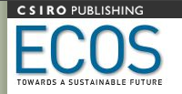
Landscope
New Internationalist
Renew
(Electronic and print access)
WME (Water, materials, energy)
(Print access)
Issue
(Electronic and print access)

